- Configure 2 slave machines in Jenkins master.

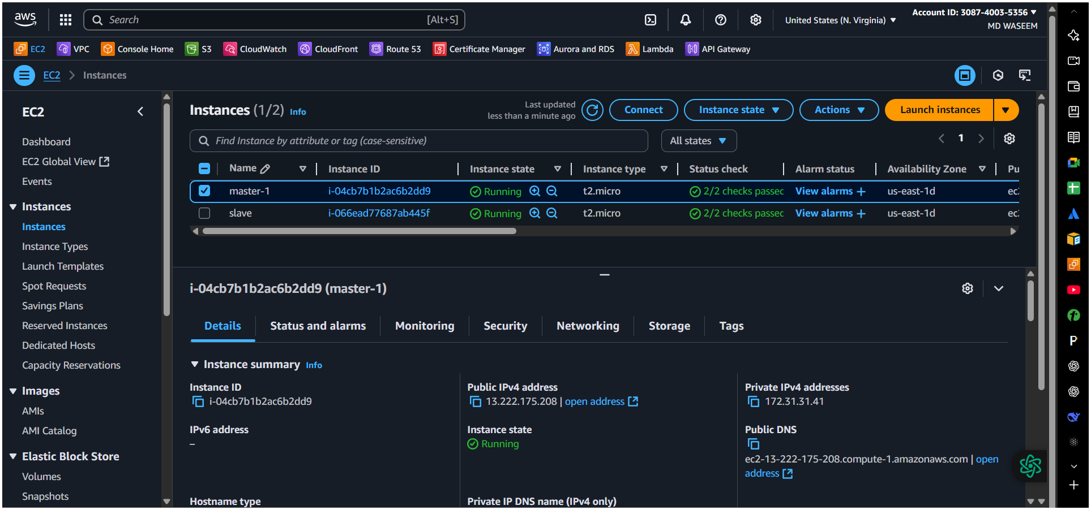
slave-1
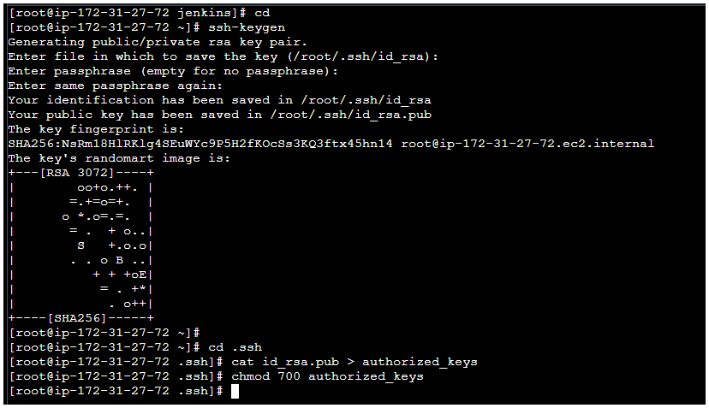

master
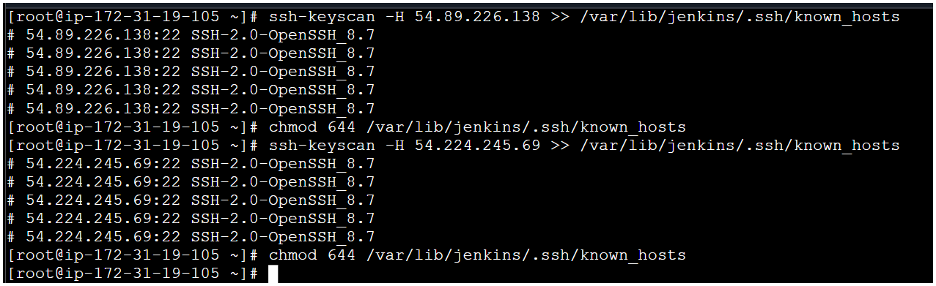

slave-2
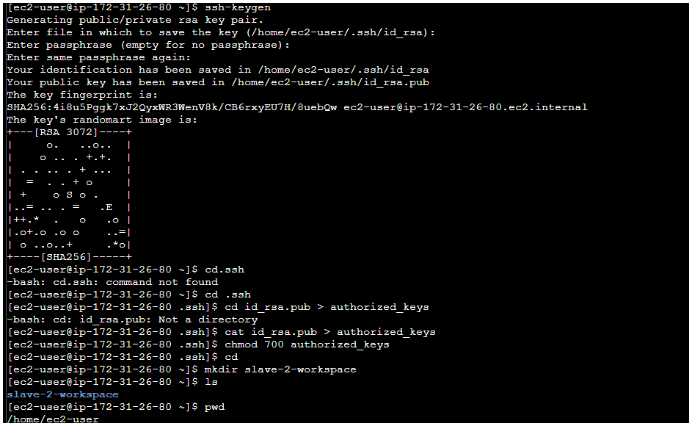
In master Jenkin’s Build In-Node error configure MonitorsReplace 1gb to 100mb(Free Disk Space ) Apply Save.
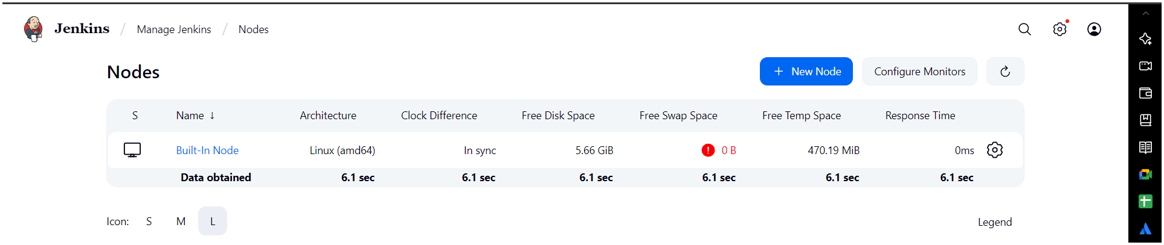
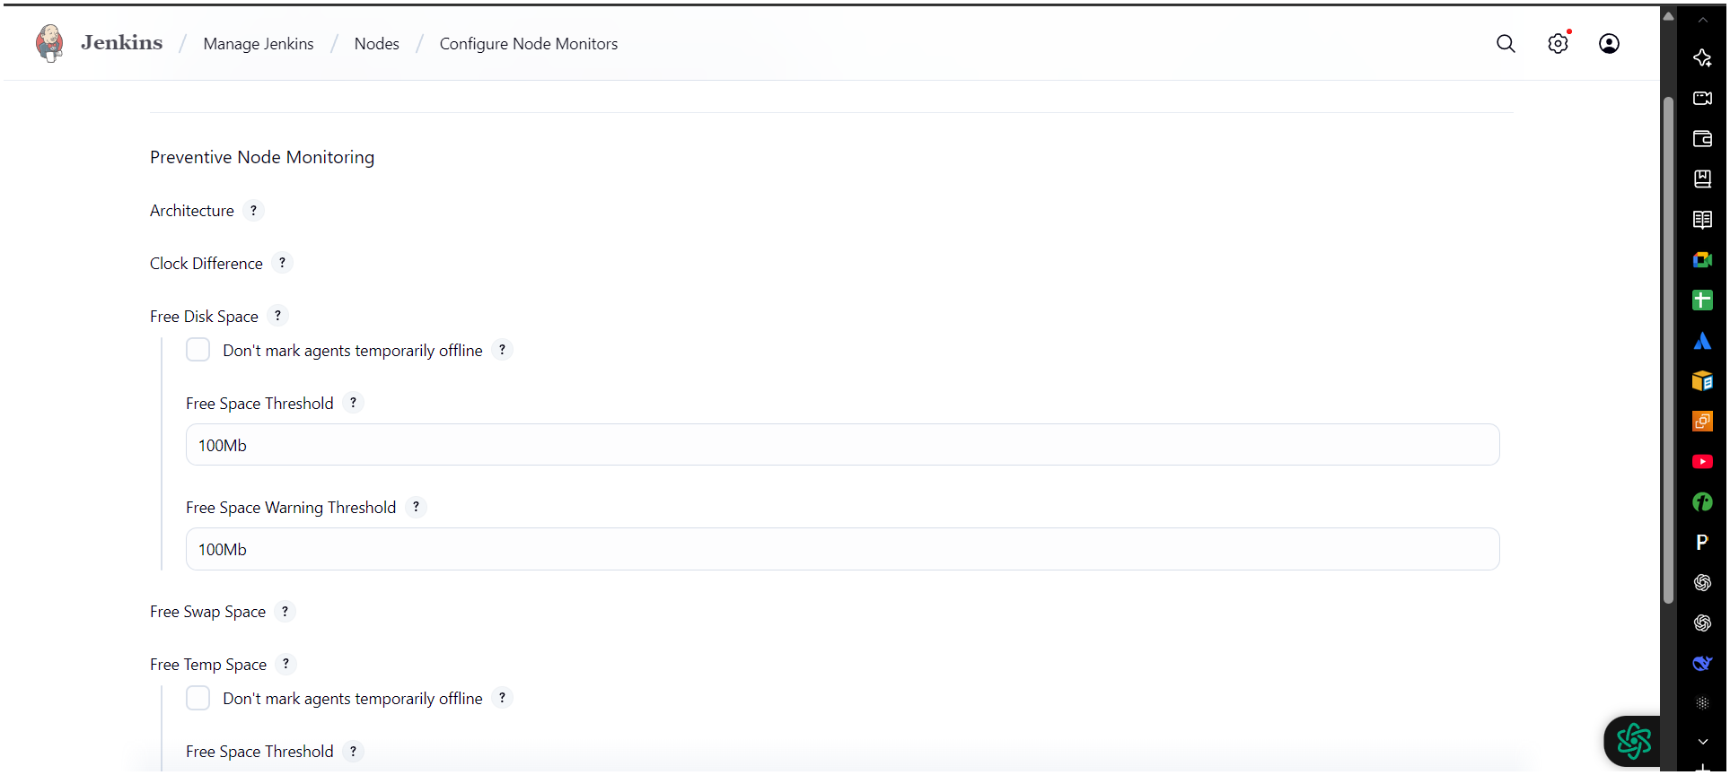

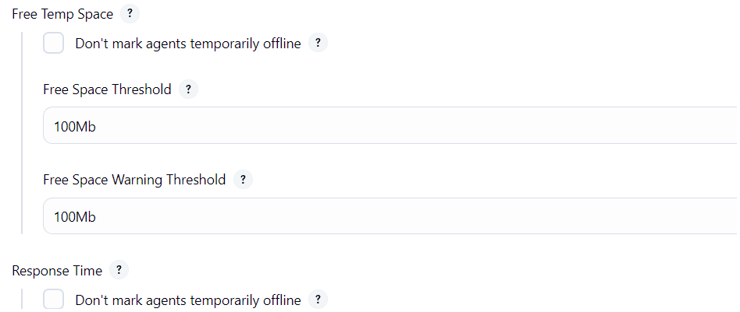
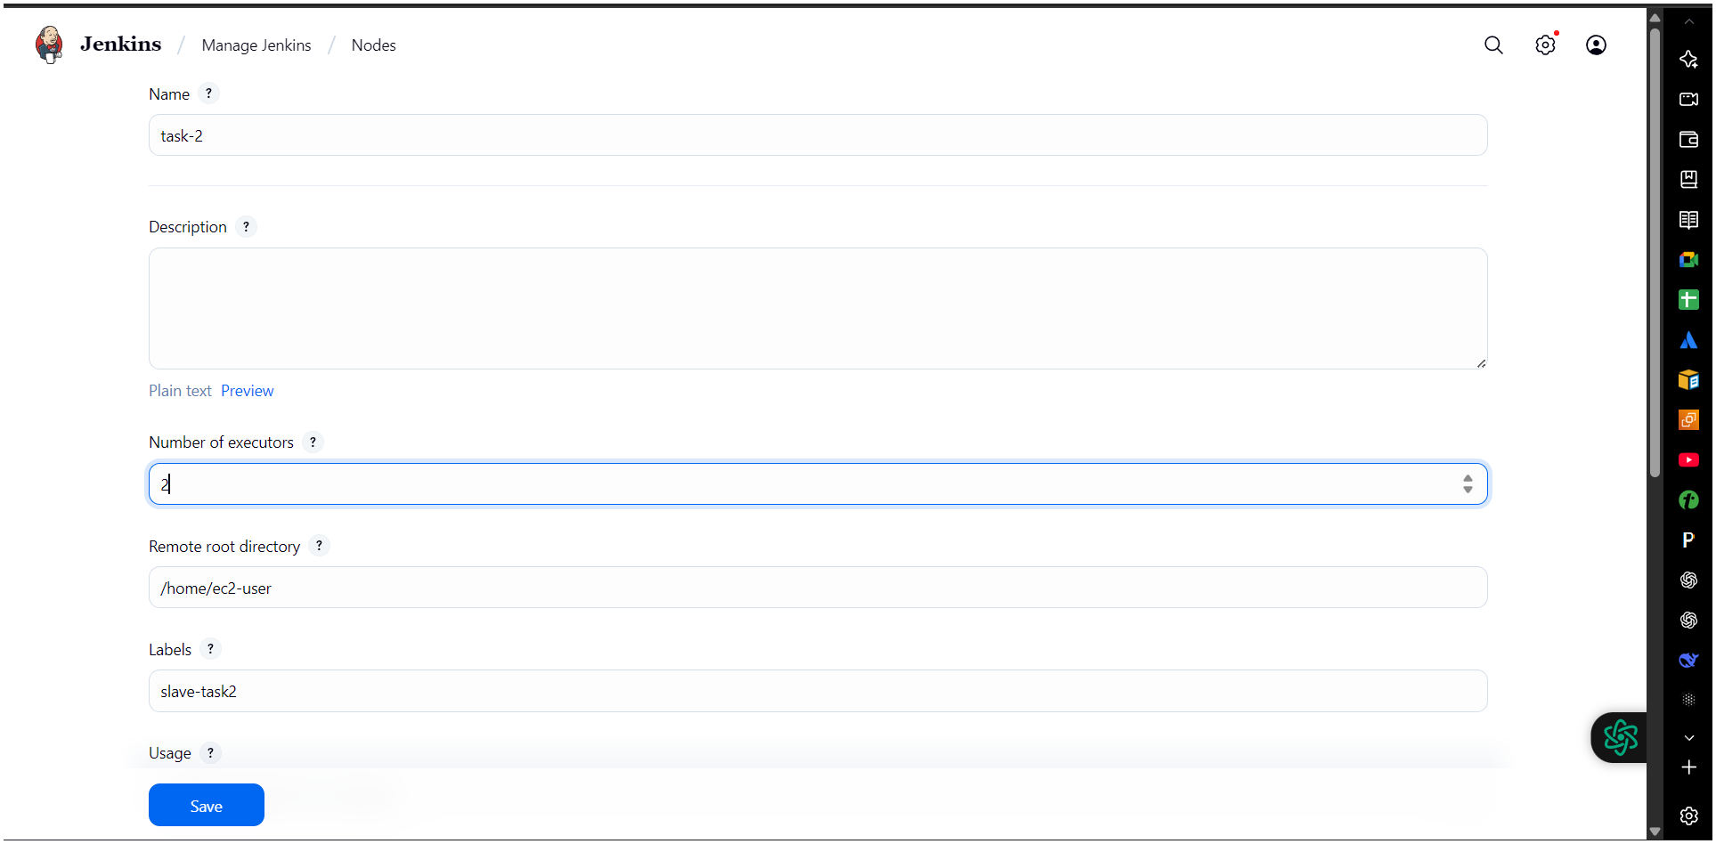
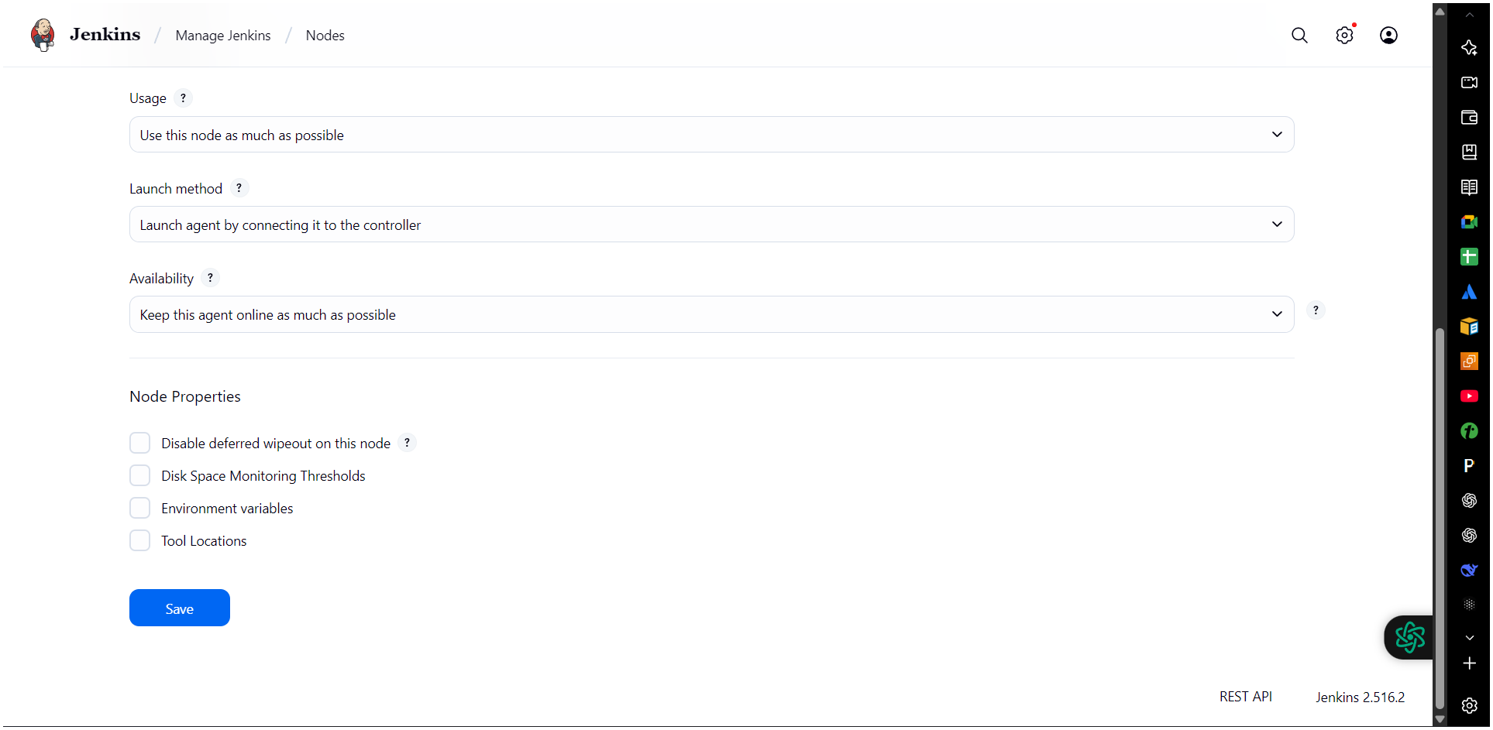
- Steps on Master Machine
1. Login to master machine.
2.Switch to root user.
3. Create Jenkins SSH directory:
mkdir -p /var/lib/jenkins/.ssh
cd /var/lib/jenkins/.ssh
. ssh-keyscan -H SLAVE-NODE-PUBLIC-IP >> /var/lib/jenkins/.ssh/known_hosts
. chown jenkins:jenkins /var/lib/jenkins/.ssh/known_hosts
. chmod 644 /var/lib/jenkins/.ssh/known_hosts
. Create the node in Jenkins GUI
. Manage Jenkins → Nodes → New Node
. Name: slave2 → Type: Permanent Agent
. Remote root directory: /home/ec2-user
. This path is taken from slave machine
. Slave ec2 → cat /etc/passwd
. chown ec2-user:ec2-user slave02-workspace
. chmod 777 slave02-workspace
. Labels: slave2 java (as you like)
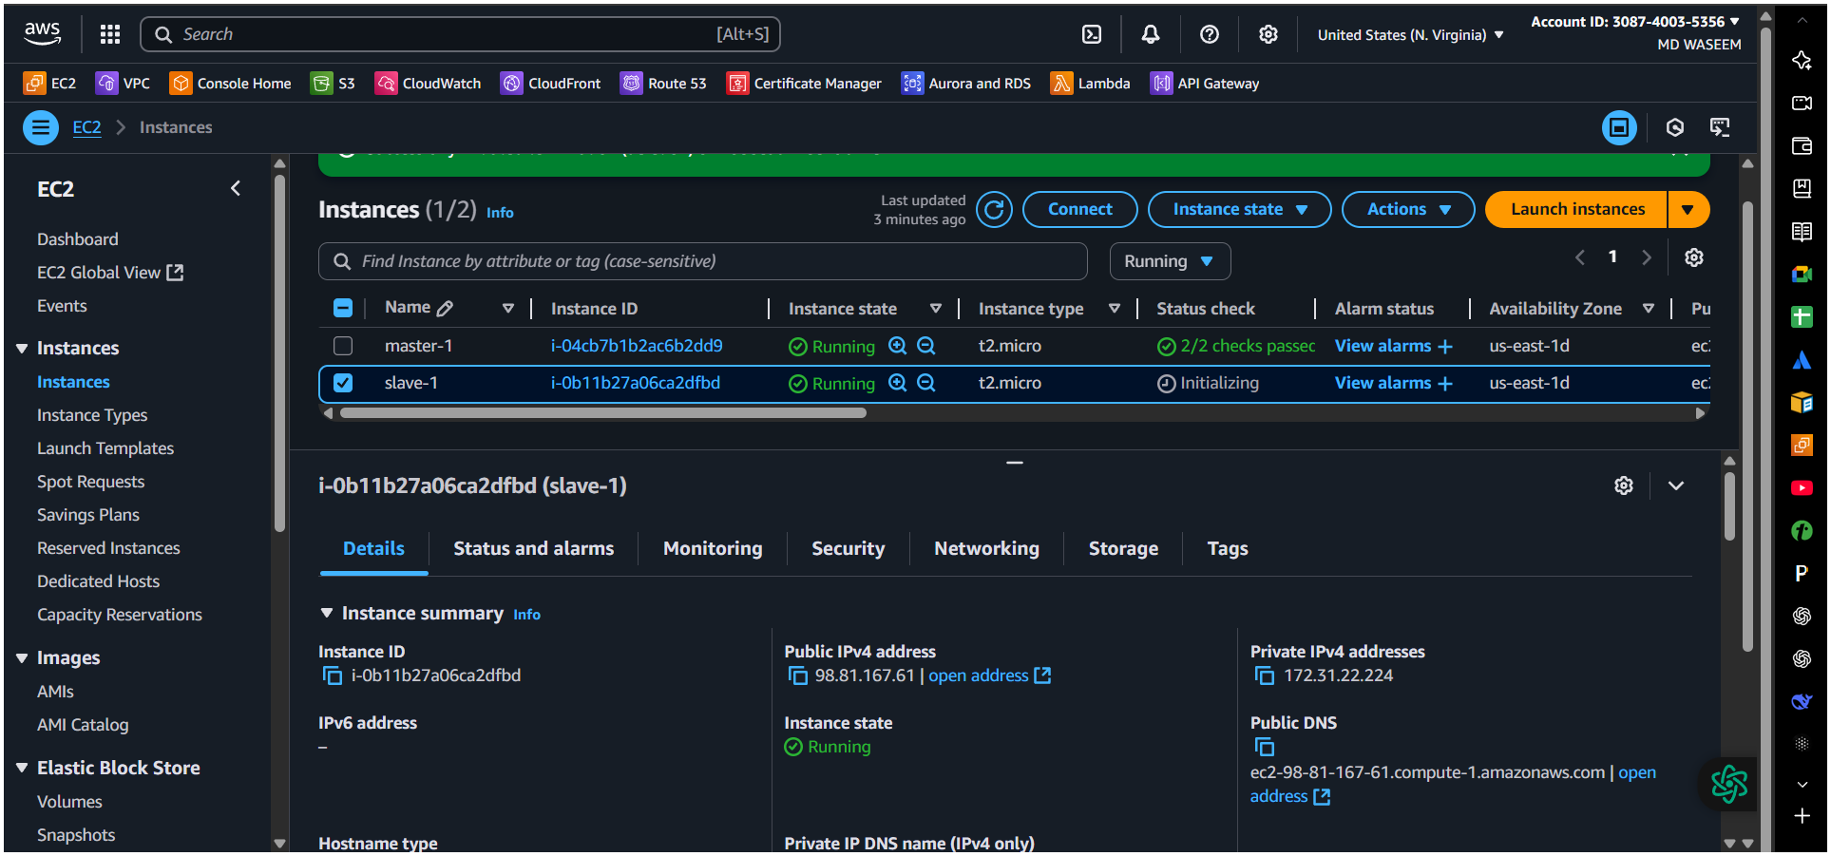
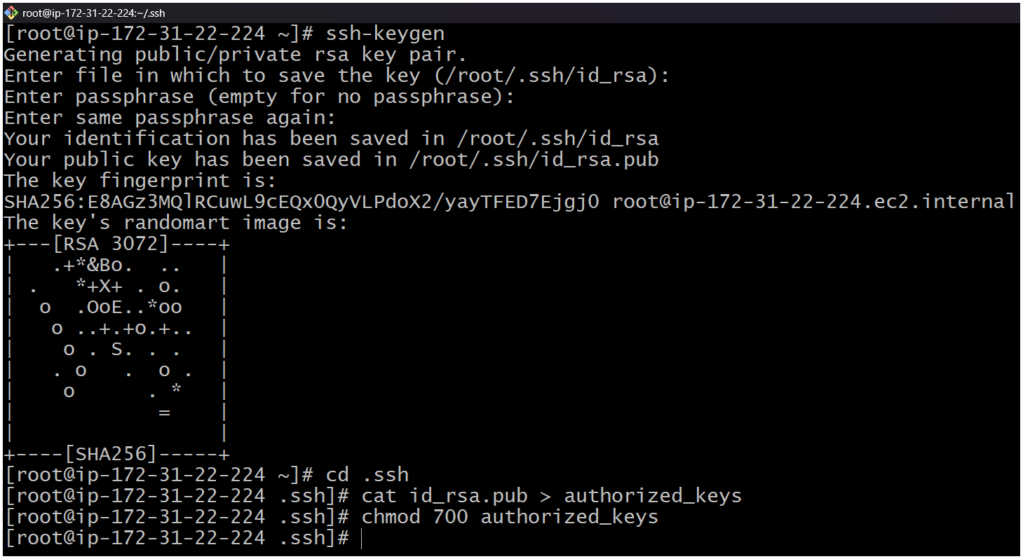
1- Create or launch two instances slave01-ec2 and slave02-ec2
2- Install java and git on both ec2
3- Sudo yum install -y git
4- sudo dnf install -y java-17-amazon-corretto
5- Copy the key gen → ssh-keygen
6- Cd .ssh
7- cat id_rsa.pub > authorized_keys
8- chmod 700 authorized_keys

Step | Steps on Master Machine  Command | What it Does | Why it is Needed
a | Login to master machineExample: ssh ec2-user@<MASTER-IP> | Opens a terminal session to the Jenkins master server. | To perform all configurations on the master node where Jenkins is running.
b | sudo -i | Switches to the root user. | Root privileges are needed to modify system directories like /var/lib/jenkins/.
c | mkdir -p /var/lib/jenkins/.sshcd /var/lib/jenkins/.ssh | Creates the .ssh directory for the Jenkins user if it does not exist (-p avoids errors if it already exists) and then moves into that directory. | Jenkins uses this folder to store SSH-related files such as keys and known_hosts for secure communication.
d | ssh-keyscan -H SLAVE-NODE-PUBLIC-IP >> /var/lib/jenkins/.ssh/known_hosts | Fetches the SSH public key fingerprint of the slave machine and appends it to the known_hosts file. -H hashes the hostname for security. | Prevents SSH from asking: “Are you sure you want to continue connecting?” when Jenkins master connects to the slave, enabling automatic and secure communication.
e | chown jenkins:jenkins /var/lib/jenkins/.ssh/known_hosts | Changes the ownership of the known_hosts file to the Jenkins user and group. | Jenkins runs as the jenkins user. It must have permission to read the file to establish an SSH connection.
f | chmod 644 /var/lib/jenkins/.ssh/known_hosts | Sets file permissions: Owner can read/write; Group can read; Others can read. | Ensures the file is secure (not writable by others) but still readable by Jenkins for SSH authentication.
Steps on Master Machine
a. Login to master machine.
b. Switch to root user.
c. Create Jenkins SSH directory:
mkdir -p /var/lib/jenkins/.ssh
cd /var/lib/jenkins/.ssh
d. ssh-keyscan -H SLAVE-NODE-PUBLIC-IP >> /var/lib/jenkins/.ssh/known_hosts
e. chown jenkins:jenkins /var/lib/jenkins/.ssh/known_hosts
f. chmod 644 /var/lib/jenkins/.ssh/known_hosts
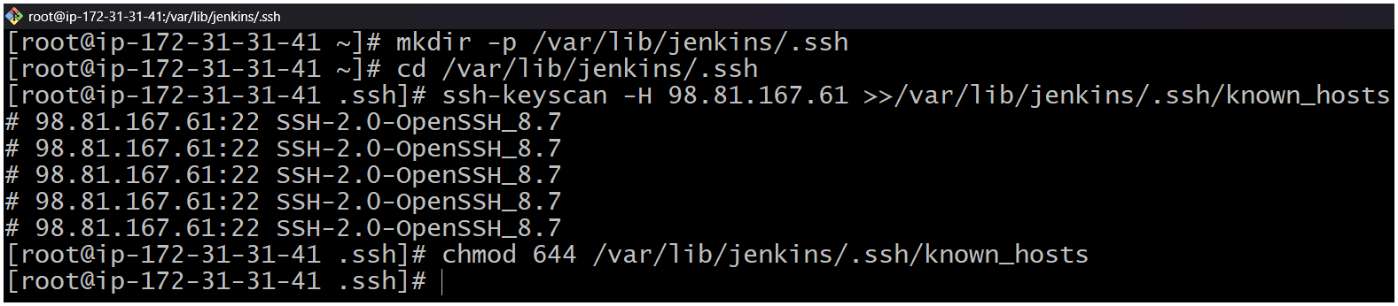
Create the node in Jenkins GUI.
1. Manage Jenkins (master) → Nodes → New Node
2. Name: slave2 → Type: Permanent Agent
3. Remote root directory: /home/ec2-user
a. This path is taken from slave machine
b. Slave ec2 → cat /etc/passwd
c. chown ec2-user:ec2-user slave02-workspace
d. chmod 777 slave02-workspace
4. Labels: slave2 java (as you like)
Usage: “Only build jobs with label expressions” (optional)
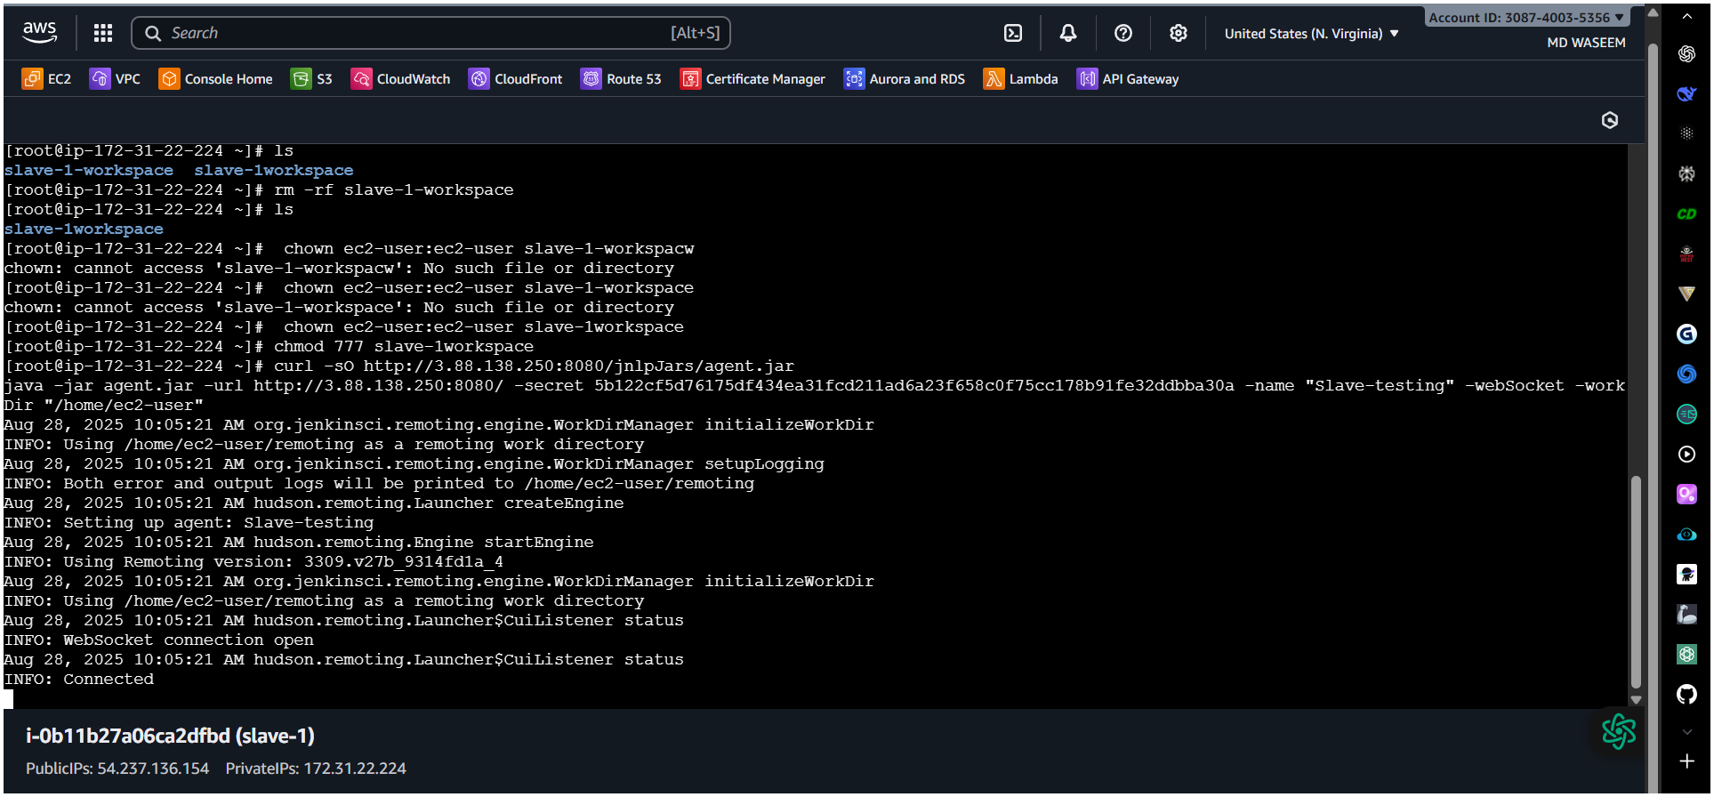
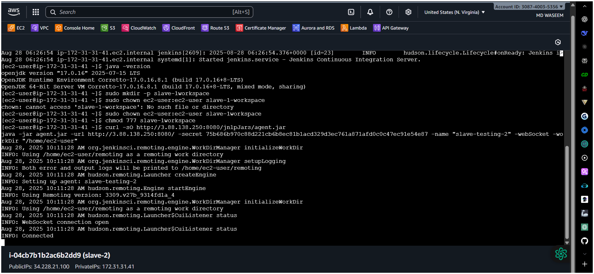
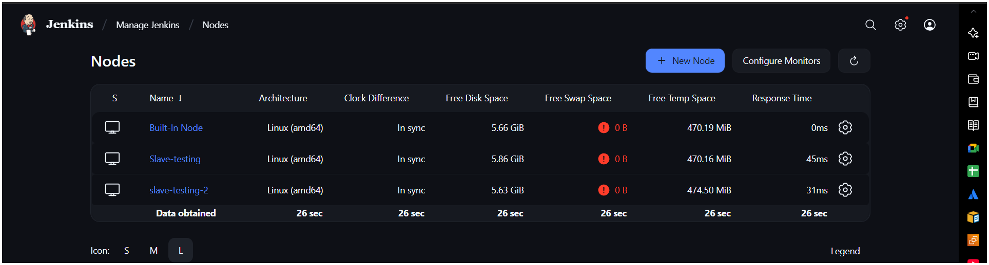
6. Launch method: Launch agents via SSH
○ Host: <NEW_AGENT_IP_OR_DNS>
○ Credentials: create/select “SSH Username with private key”
■ Username: ec2-user
■ Private key: paste content of /var/lib/jenkins/.ssh/id_rsa
from the master
○ Host Key Verification Strategy: Known hosts file (recommended)

2) Configure webhooks to Jenkins job.

✅ What is a Webhook in Jenkins?
A webhook is an HTTP callback that sends real-time data from your repository (e.g., GitHub) to Jenkins whenever a specific event occurs (like a push, PR merge, or tag creation).
Instead of Jenkins polling the repository every few minutes, the webhook notifies Jenkins immediately.

✅ Why Do We Need Webhooks?
- Instant Build Trigger – No waiting for polling; builds start as soon as changes are pushed.
- Reduces Load – Jenkins doesn’t need to continuously check the repo for changes.
- Efficient CI/CD – Improves deployment speed and automation.
- Real-Time Feedback – Developers get instant feedback for their commits.

GitHub → Webhook event → Jenkins /GitHub-webhook/ endpoint → Job
Trigger → Build runs
Create / Configure Jenkins Job
Create a Freestyle Project –(webhook-job)
Under Source Code Management, choose Git and add your
repository URL
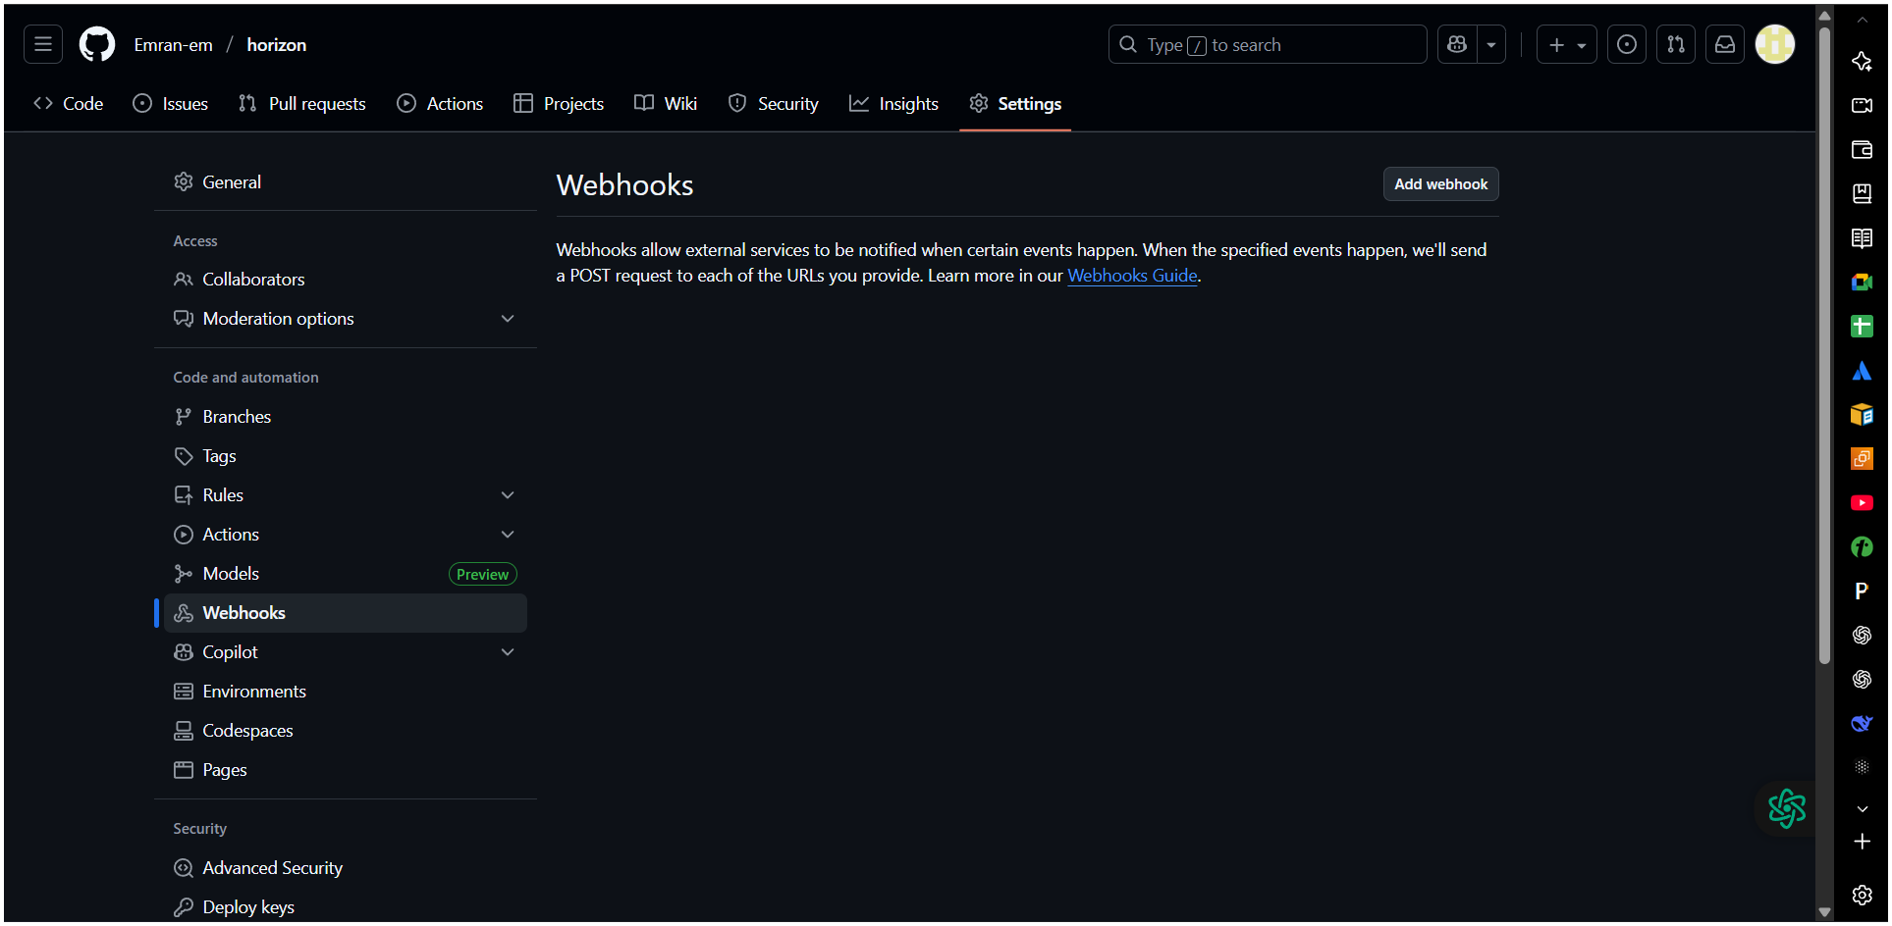
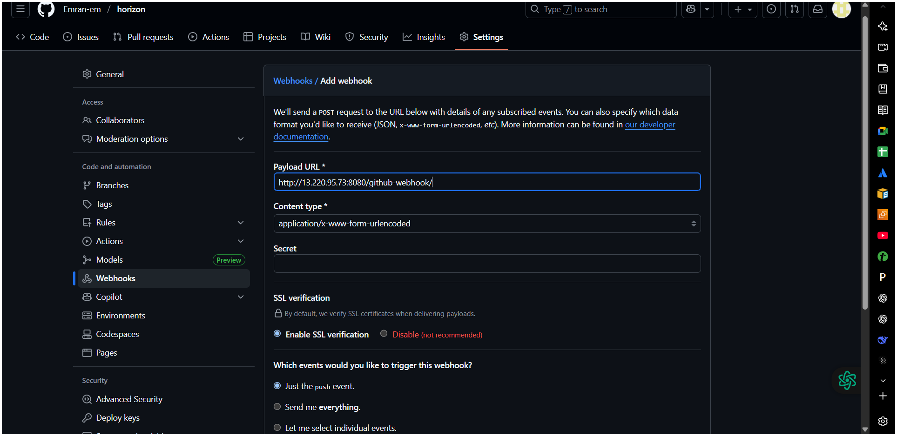
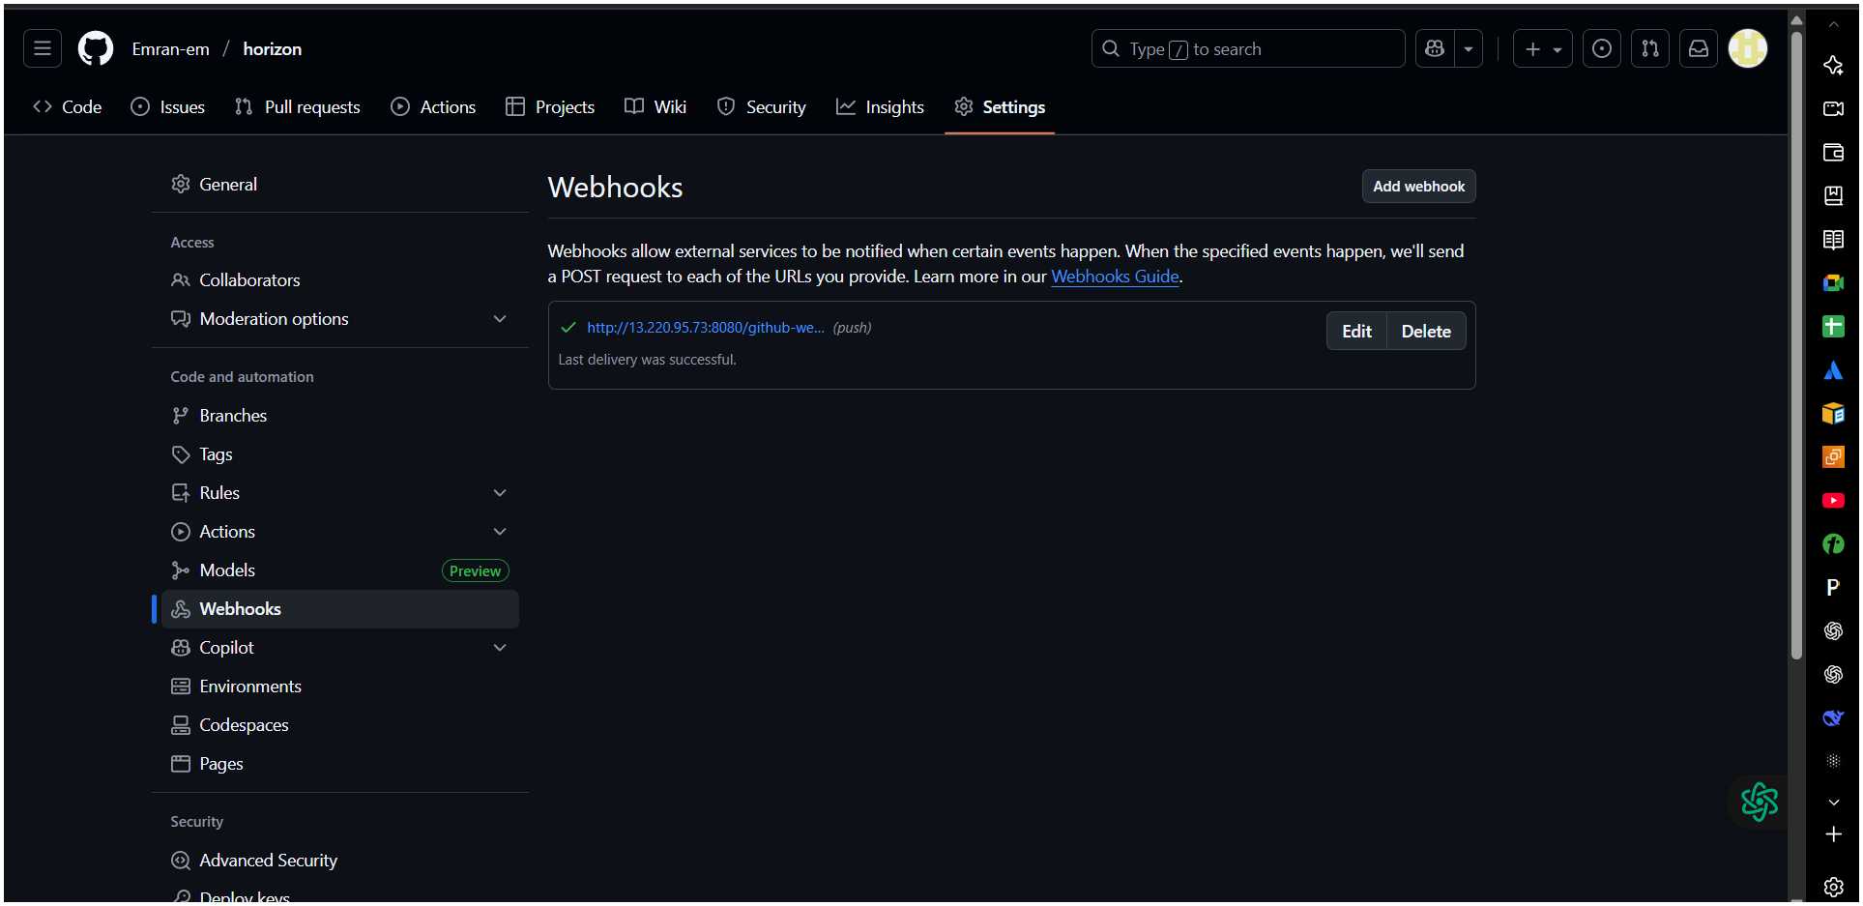
Enable Build Trigger
In your Jenkins job → Configure → Scroll to Build Triggers.
Check:
GitHub hook trigger for GITScm polling
This tells Jenkins to listen for webhook events instead of polling GitHub
periodically.
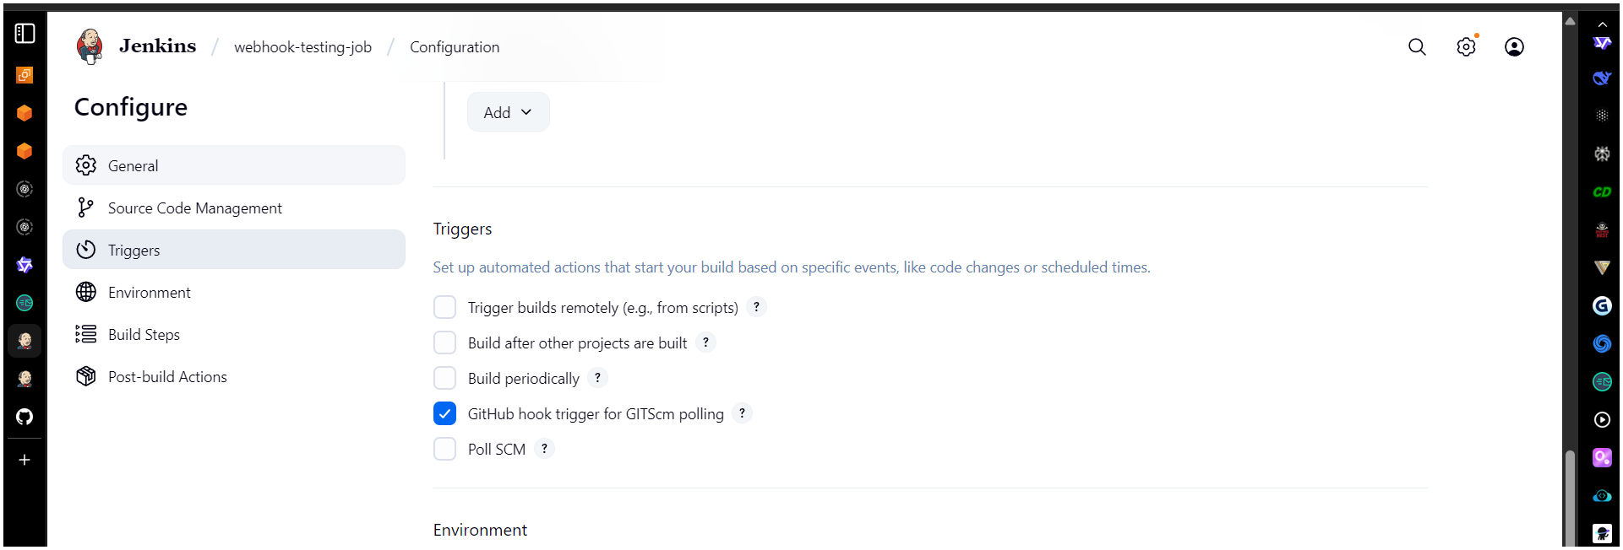
Verify
Push a commit to your GitHub repo.
Jenkins job should trigger automatically.
Check Jenkins logs to confirm webhook was received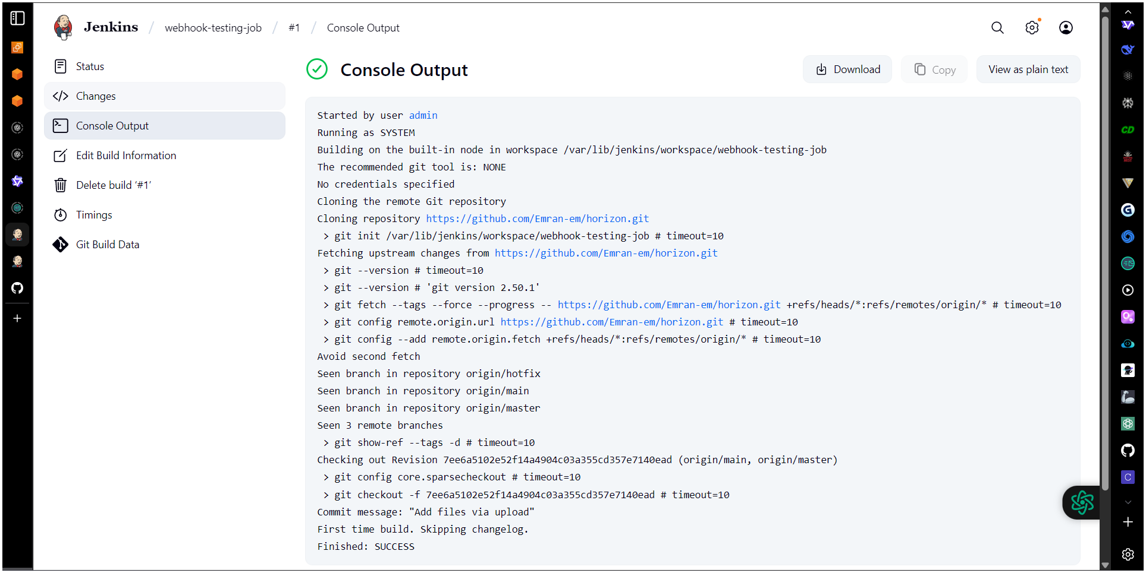

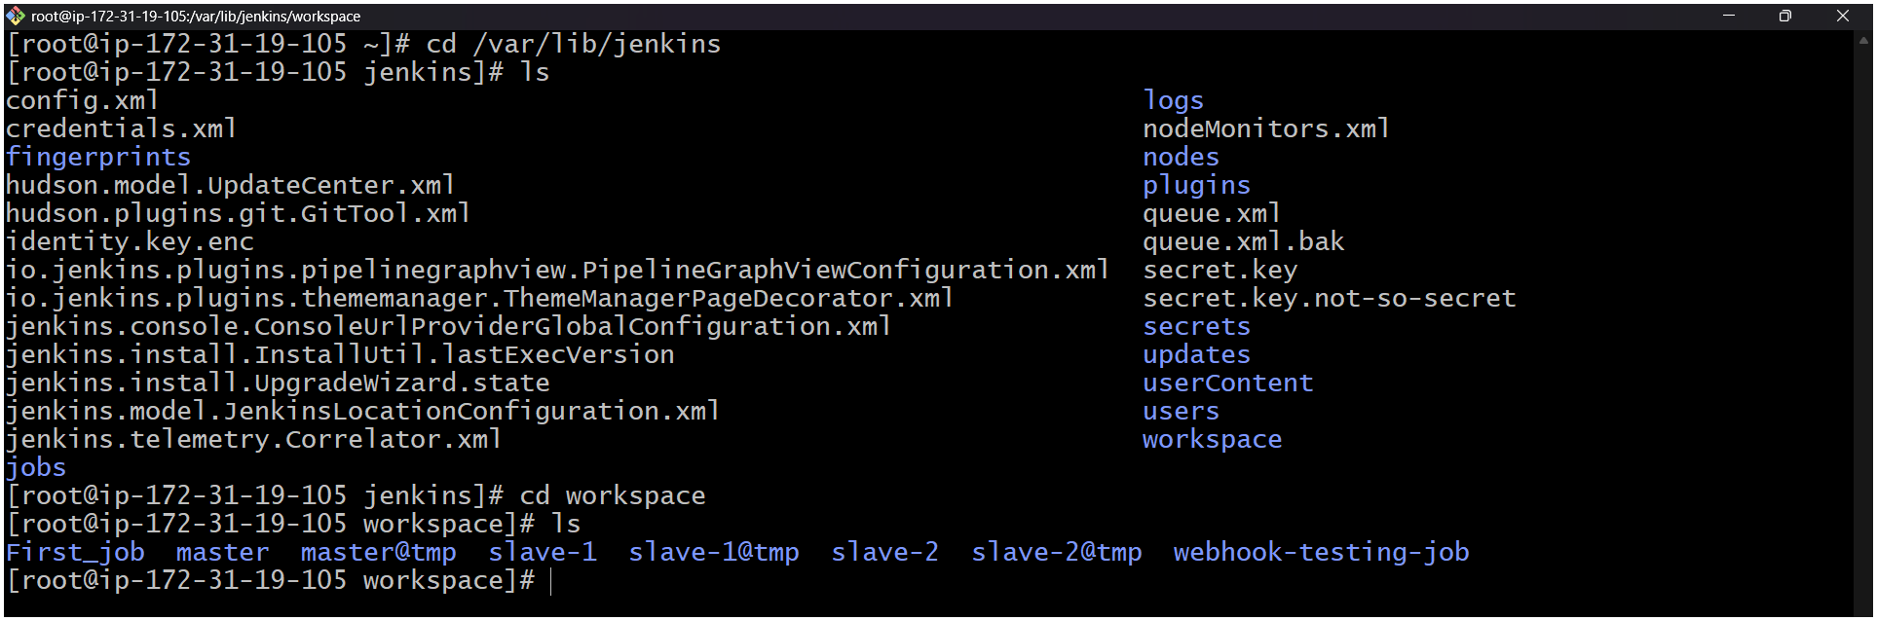
3) Configure poll scm and build periodical options in Jenkins job.
A. Poll SCM
- Go to Your Job → Configure.
- Under Build Triggers, check Poll SCM.
- Enter a schedule syntax
H/5 * * * * # Checks every 5 minutes
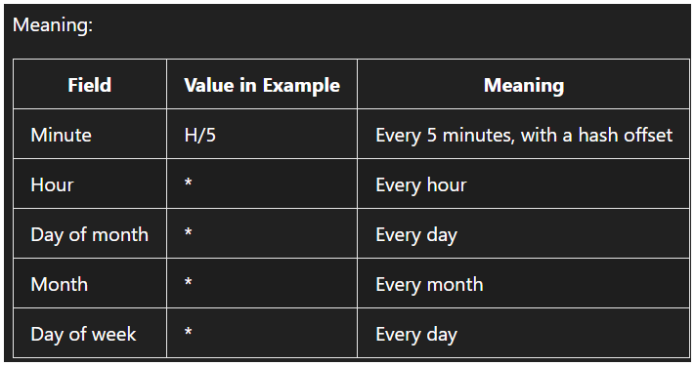
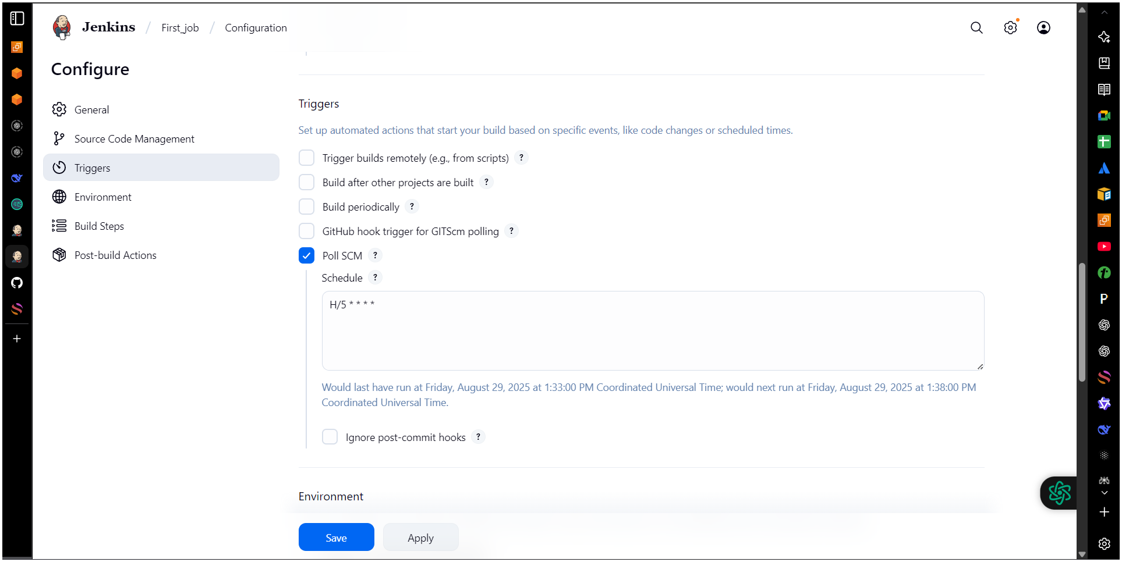
4) Take backup of Jenkins server by using bash script.
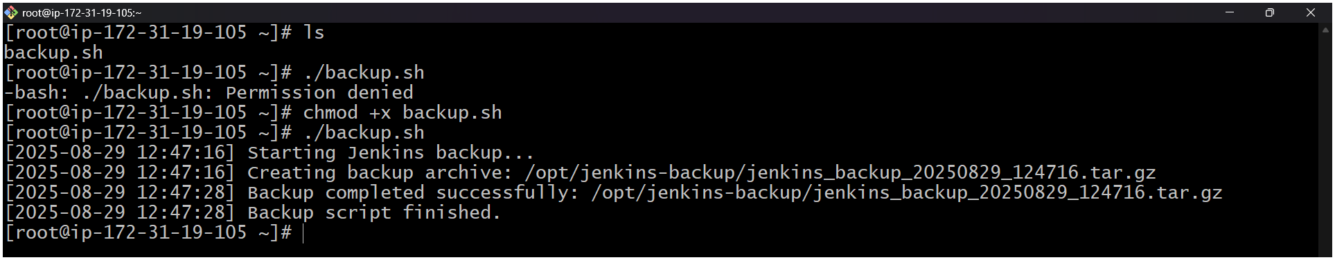
#!/bin/bash
# =============================================
# Jenkins Backup Script
# Author: DevOps Engineer
# Purpose: Backup JENKINS_HOME directory
# Output: Compressed tar.gz file with timestamp
# =============================================

# --- CONFIGURATION ---
JENKINS_HOME="/var/lib/jenkins" # Default path; change if different
BACKUP_DIR="/opt/jenkins-backup" # Where to store backups
DATE=$(date +"%Y%m%d_%H%M%S")
BACKUP_FILE="jenkins_backup_${DATE}.tar.gz"

# Optional: Retention (keep last N backups)
MAX_BACKUPS=7

# Jenkins service name (used for safe mode if needed)
JENKINS_SERVICE="jenkins"

# Enable safe backup mode? (Disable Jenkins temporarily)
SAFE_MODE=false # Set to true for zero-downtime risk

# --- END CONFIGURATION ---

# Create backup directory if it doesn't exist
mkdir -p "$BACKUP_DIR"

# Log function
log() {
echo "[$(date +'%Y-%m-%d %H:%M:%S')] $1"
}

# Check if JENKINS_HOME exists
if [ ! -d "$JENKINS_HOME" ]; then
log "ERROR: JENKINS_HOME directory not found at $JENKINS_HOME"
exit 1
fi

log "Starting Jenkins backup..."

# Optional: Stop Jenkins for consistency (safe mode)
if [ "$SAFE_MODE" = true ]; then
log "Stopping Jenkins service to ensure data consistency..."
sudo systemctl stop "$JENKINS_SERVICE"
if [ $? -ne 0 ]; then
log "ERROR: Failed to stop Jenkins service"
exit 1
fi
fi

# Create compressed backup
log "Creating backup archive: $BACKUP_DIR/$BACKUP_FILE"
tar -czf "$BACKUP_DIR/$BACKUP_FILE" -C "$(dirname "$JENKINS_HOME")" "$(basename "$JENKINS_HOME")"

# Check if tar succeeded
if [ $? -eq 0 ]; then
log "Backup completed successfully: $BACKUP_DIR/$BACKUP_FILE"
else
log "ERROR: Backup failed during archive creation"
# Restart Jenkins even if failed
if [ "$SAFE_MODE" = true ]; then
sudo systemctl start "$JENKINS_SERVICE"
fi
exit 1
fi

# Restart Jenkins after backup
if [ "$SAFE_MODE" = true ]; then
log "Restarting Jenkins service..."
sudo systemctl start "$JENKINS_SERVICE"
fi

# Enforce retention policy: Keep only last N backups
cd "$BACKUP_DIR" || exit 1
ls -t jenkins_backup_*.tar.gz | tail -n +$((MAX_BACKUPS + 1)) | while read file; do
log "Removing old backup: $file"
rm -f "$file"
done

log "Backup script finished."
5) Take backup of Jenkins using rethin backup plugin.
Step 1: Access Jenkins
1. Open your Jenkins URL in a browser: http://<your-server-ip>:8080.
2. Log in with an admin account.
Step 2: Install ThinBackup Plugin
1. Go to Manage Jenkins → Manage Plugins.
2. Click the Available tab.
3. Search for ThinBackup.
4. Check the box next to ThinBackup.
5. Click Install without restart
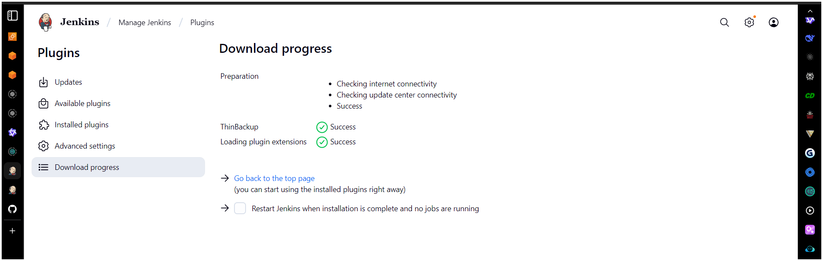
Step 3: Configure ThinBackup
1. Go to Manage Jenkins → System
2. Click Configure.
3. Set the following:Backup directory: Path where backups will be stored (e.g.,
/var/Jenkins-backup).
4. Click Save.
Navigate to manage Jenkins scroll down (you’ll see) ThinBackup
Step 4: Take Manual Backup
Cd /var/lib/Jenkins
ls
cd backup/
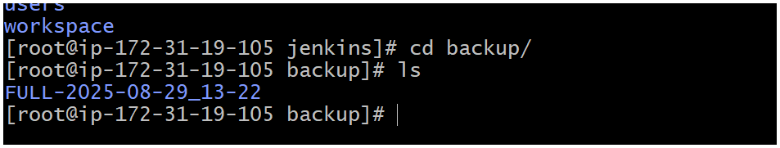

6) Setup a new Jenkins server and dump the backup taken in task4.

